**A Project Report**

**On**

**"CINEMA HUB"**

Submitted in Partial Fulfillment of the Requirement Of

Project-II (BIT156CO)

Of

Bachelor of Information Technology

**Submitted to:**



Purbanchal University

Biratnagar, Nepal

**Submitted by:**

Sagar Upadhyaya (324529)

Shubham Ghimire (324531)

Dhiraj Sapkota (324513)

**KANTIPUT CITY COLLEGE**

Putalisadak, Kathmandu

August 26, 2022

**A Project Report**

**On**

**“CINEMA HUB”**

Submitted in Partial Fulfillment of the Requirement Of

Project II-(BIT156CO)

Of

Bachelor of Information Technology

**Submitted to:**

Purbanchal University

Biratnagar, Nepal

**Submitted by:**

Sagar Upadhyaya (324529)

Shubham Ghimire (324531)

Dhiraj Sapkota (324513)

**Project Supervisor**

**Ashim Kc**

**Program Coordinator**

**KANTIPUT CITY COLLEGE**

Putalisadak, Kathmandu

August 26, 2022

**CERTIFICATE OF TOPIC APPROVAL SHEET**

It is here by informed that the topic selected by Sagar Upadhyaya, Shubham Ghimire, and Dhiraj Sapkota of BIT second semester project has been found suitable and as per the credit assigned by Purbanchal University (PU), Biratnagar, Nepal. The Project Committee has approved the following topic and supervisor for the mentioned students. This project has been completed for the prescribed period and the project embodied the result of their investigation conducted during they worked as full-time student of this institution.

Topic Approved: CINEMA HUB

_____________________ ______________________

Mr. Saroj Pandey Mr. Ashim Kc

Deputy HOD, Department of Information Technology Project Supervisor

Kantipur City College Kantipur City College

**CERTIFICATE FROM SUPERVISOR**

This is to certify that the project titled CINEMA HUB submitted by Sagar Upadhyaya, Shubham Ghimire, and Dhiraj Sapkota to the Department of Information Technology, School of Science and Technology at Kantipur City College, Kathmandu, Nepal towards the requirement for Project-II (BIT156CO) is an original work carried out by them under my supervision and guidance.

____________________

Ashim Kc

Department of Information Technology

Kantipur City College

(Project Supervisor)

**ACKNOWLEDGEMENT**

We would like to acknowledge all who have encouraged and inspired us directly or indirectly to complete this project. At first, we desire to express our deepest sense of gratitude to Purbanchal University for giving us the opportunity to present ourselves this report within the scheduled time.

We want to thank Kantipur City College for providing this opportunity by approving our project. We are incredibly grateful to our supervisor Mr. Ashim Kc for continuously supporting and guiding us in our project and providing his valuable time to complete our project.

We also are very thankful to Mr. Nishan Lamichhane and rest of the teacher who were also helpful for providing us the idea to prepare this project and for continuously motivating us to focus on our project.

We are fortunate enough to get the encouragement and feedback from our teachers and friends. Lastly, many thanks to all the people for their suggestions, feedback and support which was the most in completing our project successfully.

This project has been a wonderful experience where we have learnt and experienced many beneficial things.

With regards

Sagar Upadhyaya

Shubham Ghimire

Dhiraj Sapkota

**ABSTRACT**

Maintaining different management records like movie details, cinema details in cinema along with its different ticket booking related information using system can be the best way to practice. So, such kind of project is CINEMA HUB which we built using C++ language. This project is related to ticket booking and cinema management system. This project is developed with the major objective of providing management facilities to admin, manager, and staff of the cinema and to provide customer the easy access to book movie tickets.

This project report on CINEMA HUB consists of background and significance of the project with objectives, features and problem-solving statement of the project which shows the detail information about the research done about existing system and limitation of them and its working mechanism with proper functionality. We have implemented different important features like booking ticket, cancelation of tickets, billing of tickets, adding cinema and movie records and their manipulation and so on. And we are hopeful that this project CINEMA HUB might be helpful for most of the users who desire for maintaining systematic record of the cinema along with its booking details.

**LIST OF TABLES**

|  |  |  |
| --- | --- | --- |
| **Table no.** | **Table name** | **Page no.** |
| 1 | Team Structure and Role | 11 |
| 2 | Functional Requirement | 15 |
| 3 | Data Structure | 16 |
| 4 | Requirement Gathering Process | 12 |

# **ABBREVATIONS**

* CH: CINEMA HUB
* HDD: Hard Disk Drive
* IDE: Integrated Development Environment
* RAM: Random Access Memory
* GUI: Graphical User Interface

**TABLE OF CONTENT**

**Table of Contents**

ACKNOWLEDGEMENTiii

ABSTRACTiv

LIST OF TABLESv

ABBREVATIONSv

Chapter 1: Introduction1

1.1 Project background1

1.2 Project significance1

1.3 Problem solving statements1

1.4 Project objectives2

1.5 Project features2

1.6 Team structure and roles2

Chapter 2: System Analysis3

2.1 Literature Review3

2.1.1 Limitation of Existing projects3

2.2 Requirement gathering process3-4

2.3 Feasibility study4

2.3.1 Technical feasibility4

2.3.2 Schedule feasibility 4

Chapter 3: System Design5

3.1 Functional analysis5

3.1.1 Header files5

3.1.2 Classes and Structure6

3.2 Algorithm7-14

3.3 Flowchart.15-25

3.4 Gantt chart 25

Chapter 4: System Development and Implementation26

4.1 Programing platform (Tools and technology used)26

4.1.1 Software specification26

4.1.2 Hardware specification26

Chapter 5: Conclusion and future enhancement27

5.1 Conclusion27

5.2 Future enhancement27

REFERENCES28

APPENDIXES29

**APPENDIXES** 129

1.1 Main Menu29

1.2 Admin Login29

1.3 Admin Menu30

1.4 Customer Menu30

1.5 Manager Login31

1.6 View Customer31

1.7 Booking132

1.8 Booking232

**CHAPTER 1: INTRODUCTION**

* 1. **Project Background**

CINEMA HUB is the project that helps in maintaining different management records like movie details, cinema details in cinema along with its ticket booking related information. This system can be best used to maintain the record of the admin, manager, staff of the cinema and customer along with ticket booking facilities which allows different access to the authorized person like add, modify, remove, search, and view the records. The records may include cinema details, movie details, customer details, billing details and so on.

The interface of this project is quite easy to interact as this project is coded in user understandable form. This system consists of distinct functions and has menu options which are easily understandable by the users. As the program name itself describes, it is a system with availability of multiple features where user can create, search, modify, update, and view different management records of the cinema, movie and booking details. This system also has a security function so that only authorized individuals can operate it. The above details provide a little background of the system which is the purpose of this report.

* 1. **Project Significance**

This project is concerned with making an application using the C++ programming language and the main significance of this project is to help understand the use of C++ programming language and as a medium to make the imagination of any programmer into the reality.

* 1. **Problem Statement**

This project provides user the ability to create different login details of admin, manager, staff, and customer so that only the authorized individuals can have access to the records. We have created different labled like mechanism so that one can have particular control over data. To maintain those records different classes, structures, file handling functions and operations has been used in the program and to demonstrate our entire project we have used two major problem-solving technique they are: algorithm and flowchart.

* 1. **Project Objectives**
* To provide user the ticket booking facilities of movies.
  1. **Project Features**
* Booking of different seats of cinema
* Cancelation of existing booked movie
* Different logins for user
* Implementation of graphics
* billing of movie tickets
  1. **Team Structure and Role**

|  |  |
| --- | --- |
| **Team Members** | **Task Performed** |
| Sagar Upadhyaya | Coding, documentation, design, debugging & research |
| Shubham Ghimire | Logic development, documentation, design, debugging |
| Dhiraj Sapkota | Coding, documentation, debugging, research & analysis |

**CHAPATER 2: SYSTEM ANALYSIS**

**2.1 Literature review**

With the change in time and technology, the system of record keeping was digitalized and creating and maintaining the records in any kind of system has become much more efficient and more easily accessible. Nowdays, many systems have been developed continuously as an academic project. Like the same we also developed the project CINEMA HUB.

During our research we found some management and ticket booking related project that has already been developed like **Ticket Reservation System**. But those projects were lacking some of the key features. The interface of the project was not user friendly, and this system also lacked security function. Likewise, those projects did not have the feature to manipulate some of the records. Hence, we included all the mentioned features in our program CINEMA HUB.

**2.1.1 Limitation of existing system**

* Lacked to manipulate different records like movie details
* Lacked to maintain validation of the records
* Unmanaged seats booking process
* No provision of control and access to authorized individuals

**2.2 Requirement gathering process**

|  |  |  |  |
| --- | --- | --- | --- |
| **Requirement No.** | **Requirement Name** | **Requirement description** | **Function Number** |
| 1 | Login | To make cinema hub secured | 1 |
| 2 | Create | To add record of the manager, staff, cinema, movie & customer | 2 |
| 3 | Display | To display existing record of manager, staff, movie, cinema & customer | 3 |
| 4 | Edit | To edit details of manager, staff, movie, cinema & customer | 4 |
| 5 | Search | To search existing record of manager, staff, movie, cinema & customer | 5 |
| 6 | Remove | To delete existing record of manager, staff, movie, cinema & customer | 6 |
| 7 | Booking | To maintain ticket booking | 7 |

**2.3 Feasibility study:**

In a feasible study we performed feasibility analysis of a current system and the proposed system. Feasibility study is done to identify the deficiencies in the current system and find the objective of the proposed system. There are many types of study that needs to be consider but following are the major study we performed while developing this project.

**2.3.1 Technical Feasibility**

Here we analyze the technical aspects of the project. The various technical aspects such as hardware and software were taken into consideration while developing this project.

Further we also make sure that this software is feasible for the person who uses it.

**2.3.2 Schedule Feasibility**

In this feasibility study we prepared our planned Gantt chart according to our development model.

**CHAPTER 3: SYSTEM DESIGN**

**3.1 Functional Analysis**

This system contains distinct functions, header files that helps in running our project. All the header files and functions used in our project are given below along with their characteristics and descriptions:

**3.1.1 Header Files**

|  |  |
| --- | --- |
| **Header file** | **Description** |
| #include<iostream.h> | All standard library functions for file input and output are included on iostream.h |
| #include<conio.h> | All console input/output functions are included in conio.h |
| #include<graphics.h> | All graphical functions are included on graphics.h |
| #include<dos.h> | dos.h header file provide us easy access to use function for date and time. |
| #include<math.h> | math.h contains function for handling different mathematical operation. |
| #include<string.h> | string.h contains function for handling string operations. |
| #include<ctype.h> | ctype.h helps to manipulate character-oriented functions. |
| #include<fstream.h> | fstream.h helps to handle different file operations |
| #include<stdlib.h> | stdlib.h contains function for dynamic memory allocation |
| #include<process.h> | process.h helps to perform process related functions. |

**3.1.2 Classes & Structure**

|  |
| --- |
| **Class** |
| Main_menu |
| Admin |
| Manager |
| Staff |
| Customer |
| Manager_details |
| Staff_details |
| Cinema_details |
| Customer_details |
| Login |
| Shapes |

|  |
| --- |
| **Structure** |
| Details_customer |
| Details |
| Ticket_booking |
| Seats |

**3.2 Algorithm**

Step 1: Start

Step 2: Display Login Interface: choose

1. Admin login
2. Manager login
3. Staff login
4. Customer login
5. Exit

Step 3: if user choose 1 go to step 4

Else if user choose 2 go to step 37

Else if user choose 3 go to step 41

Else if user choose 4 go to step 52

Else terminate the program

Step 4: Display admin registration form if already register then go to

step 5 else register and go to step 5

Step 5: Display login page for admin

Step 6: Input username and password if true then display login successful

and go to step 7 else display Error!! Please try again and goto step 5

Step 7: Display Admin menu choose:

1. Manage manager
2. Manage Staff
3. Manage Cinema
4. Manage Movie
5. Book movie
6. Exit

Step 8: if user choose 1 go to step 9

Else if user choose 2 go to step 16

Else if user choose 3 go to step 23

Else if user choose 4 go to step 30

Else if user choose 5 go to step 61

Else go to previous menu i.e., step 2

Step 9: Display manage manager page choose:

1. Add
2. Remove
3. View
4. Modify
5. Search
6. Back

Step 10: if user choose 1 then display form to add manager and go to step 11

Else if user choose 2 then go to step 12

Else if user choose 3 then go to step 13

Else if user choose 4 then go to step 14

Else if user choose 5 then go to step 15

Else go to previous menu i.e step 9

Step 11: Input Name, user id, Password, position, cinema, and phone no and return to step 9

Step 12: Input The manager id to remove particular manager record and press Yes/No and return to step 9

Step 13: Display Manager records like Name, user id, Password, position,

cinema and phone no and return to step 9

Step 14: Input manager id to modify the particular manager record, modify it and return to step 9

Step 15: Input manager id to show the particular manager record and return to step 9

Step 16: Display manage Staff page choose:

1. Add
2. Remove
3. View
4. Modify
5. Search
6. Back

Step 17: if user choose 1 then display form to add staff and go to step 18

Else if user choose 2 then go to step 19

Else if user choose 3 then go to step 20

Else if user choose 4 then go to step 21

Else if user choose 5 then go to step 22

Else go to previous menu i.e step 16

Step 18: Input Name, user id, Password, supervisor, cinema, and phone no and return to step 16

Step 19: Input the staff id to remove particular staff record and press Yes/No and return to step 16

Step 20: Display staff records like Name, user id, Password, supervisor,

cinema and phone no and return to step 16

Step 21: Input staff id to modify the particular staff record, modify it and return to step 16

Step 22: Input staff id to show the particular staff record and return to step 16

Step 23: Display manage cinema page choose:

1. Add
2. Remove
3. View
4. Modify
5. Search
6. Back

Step 24: if user choose 1 then display form to add cinema and go to step 25

Else if user choose 2 then go to step 26

Else if user choose 3 then go to step 27

Else if user choose 4 then go to step 28

Else if user choose 5 then go to step 29

Else go to previous menu i.e step 23

Step 25: Input Name, address, manager, no of staff and phone no and return to step 23

Step 26: Input cinema name to remove particular cinema record and press Yes/No and return to step 23

Step 27: Display cinema records like Name, address, manager, no of staff, no of audi and phone no and return to step 23

Step 28: Input cinema name to modify the particular cinema record, modify it and return to step 23

Step 29: Input cinema name to show the particular cinema record and return to step 23

Step 30: Display manage movie page choose:

1. Add
2. Remove
3. View
4. Modify
5. Search
6. Back

Step 31: if user choose 1 then display form to add movie and go to step 32

Else if user choose 2 then go to step 33

Else if user choose 3 then go to step 34

Else if user choose 4 then go to step 35

Else if user choose 5 then go to step 36

Else go to previous menu i.e., step 30

Step 32: Input movie Name, Release-date, major cast, director, and time of show and return to step 30

Step 33: Input movie name to remove particular movie record and press Yes/No and return to step 30

Step 34: Display cinema record like Name, Release-date, major cast, director, and time of show and return to step 30

Step 35: Input movie name to modify the particular movie record, modify it and return to step 30

Step 36: Input movie name to show the particular movie record and return to step 30

Step 37: Display login page for manager

Step 38: Input username and password if true then display login successful

and go to step 39 else display Error!! Please try again and goto step 37

Step 39: Display manger menu choose:

1. Manage Staff
2. Manage Movie
3. Book movie
4. Exit

Step 40: if user choose 1 go to step 16

Else if user choose 2 go to step 30

Else if user choose 3 go to step 61

Else go to previous menu i.e., step 2

Step 41: Display login page for staff

Step 42: Input username and password if true then display login successful

and go to step 43 else display Error!! Please try again and goto step 41

Step 43: Display staff menu choose:

1. Manage client
2. Book movie
3. Exit

Step 44: if user choose 1 go to step 45

Else if user choose 2 go to step 61

Else go to previous menu i.e step 2

Step 45: Display manage customer page choose:

1. Add
2. Remove
3. View
4. Modify
5. Search
6. Back

Step 46: if user choose 1 then display form to add customer and go to step 47

Else if user choose 2 then go to step 48

Else if user choose 3 then go to step 49

Else if user choose 4 then go to step 50

Else if user choose 5 then go to step 51

Else go to previous menu i.e step 43

Step 47: Input customer Name and password and return to step 45

Step 48: Input customer name to remove customer and press Yes/No and return to step 45

Step 49: Display customer details like name, no of customer and return to step 45

Step 50: Input customer name to modify the customer record and return to step 45

Step 51: Input customer name to show the customer record and return to step 45

Step 52: Display login option for customer choose:

1. Login
2. Register
3. Exit

Step 53: if user choose 1 then display customer login form and go to step 54

Else if user choose 2 then display registration form go to step 55

Else go to previous menu i.e., step 2

Step 54: Input username and password if true then go to step 56 else display Error!! Please

try again and goto step 52

Step 55: display customer register and after registration go to step 54

Step 56: display customer menu: choose

1. Modify pass
2. History
3. Book movie
4. Exit

Step 57: if user choose 1 then display password changing form and go to step 58

Else if user choose 2 then go to step 59

Else if user choose 3 then go to step 61

Else go to previous menu i.e 52

Step 58: Input username, current password, new password and configure password and if login succesful goto step 52 else display Error!! Please try again and goto step 57

Step 59: Display the history page

Step 60: Display the movie list along with name that customer has booked and goto step 56

Step 61: input valid customer id and contact number

Step 62: display available cinema

Step 63: choose appropriate cinema

Step 64: display available movie

Step 65: choose appropriate movie

Step 67: display available time

Step 68: choose appropriate time

Step 69: display audi

Step 70: choose no. of seats you want to book

Step 71: display Are you sure you want to book(Y/N)

Step 72: If yes display your ticket is booked successfully and goto step 74

Step 73: If no display sorry your booking is cancelled and goto step 56

Step 74: display billing information and goto step 56

Step 75: stop

**3.3 Flowchart**

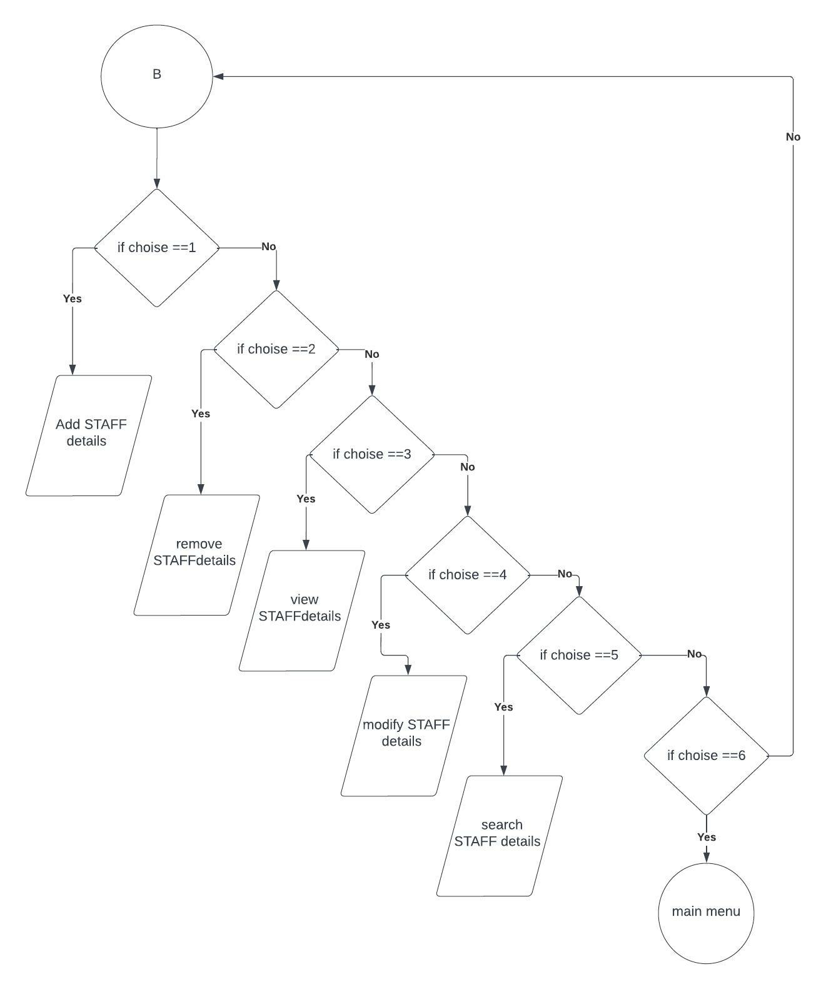

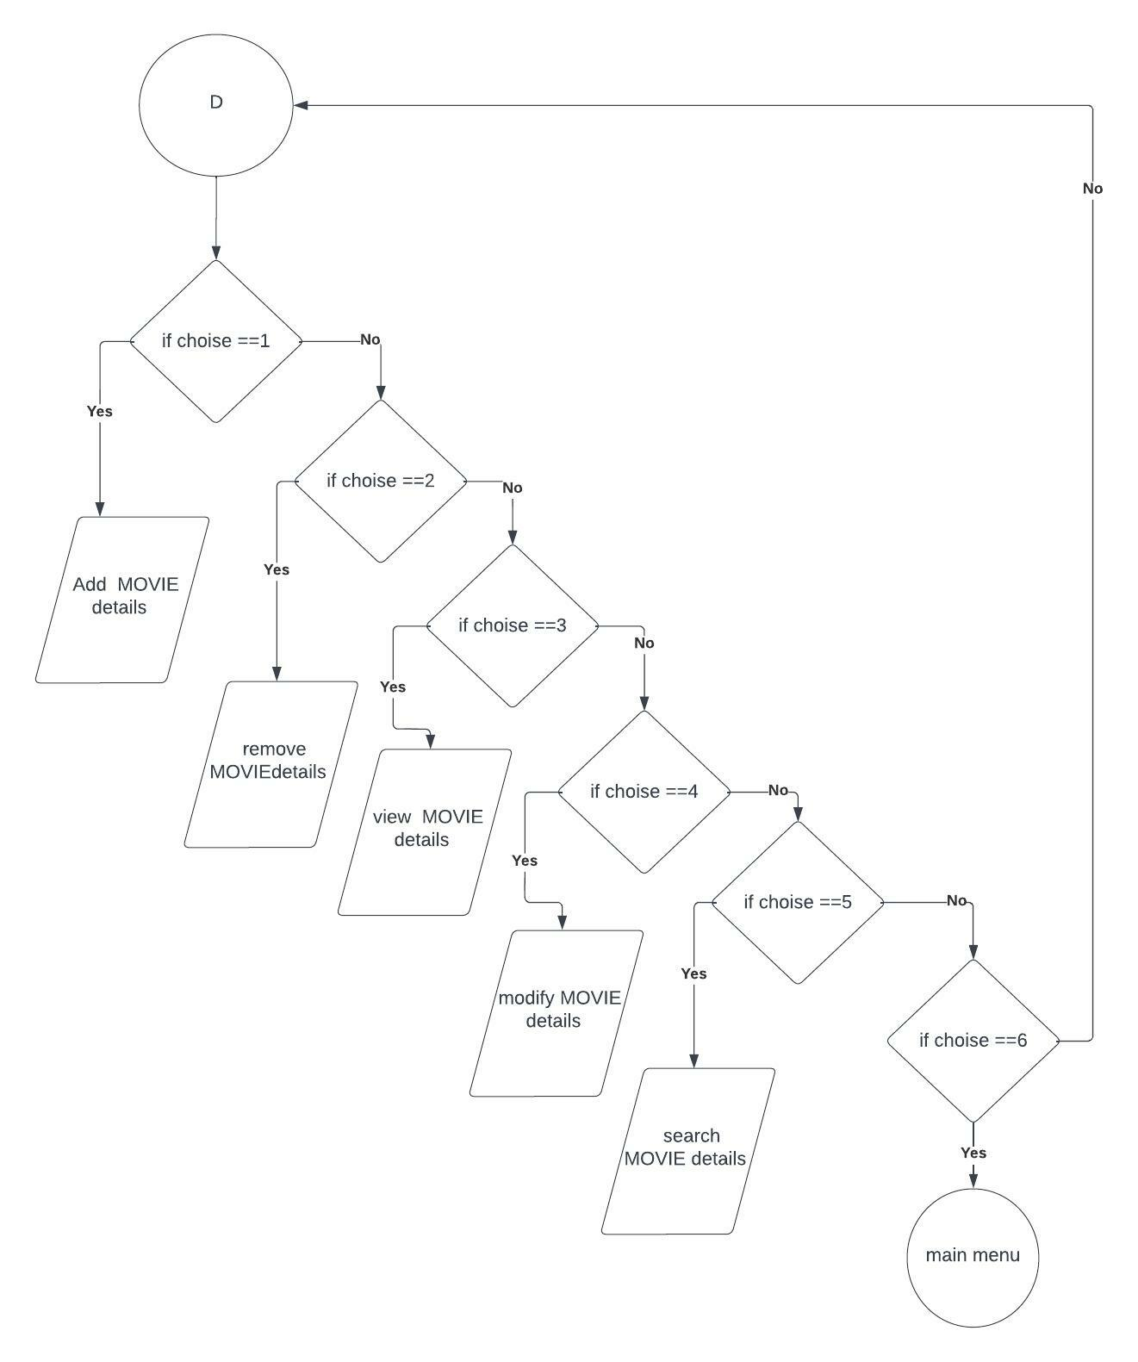

No

No

**3.4 Gantt Chart**

|  |  |  |  |  |  |  |
| --- | --- | --- | --- | --- | --- | --- |
| Task Name | 2022 | | | | | |
| **March 1** | **April1** | **May 1** | **June 1** | **July 1** | **Aug 26** |
| System Analysis |  |  |  |  |  |  |
| System Design |  |  |  |  |  |  |
| Coding |  |  |  |  |  |  |
| Debugging and Testing |  |  |  |  |  |  |
| Documentation |  |  |  |  |  |  |

# **Chapter 4: System Development and Implementation**

## 

**4.1 Programing platform (Tools and technologies used)**

**4.4.1 Software Specifications**

Computer software specification we have used for development:

* Operating System: Windows 10 Operating System
* IDE: Dev C++ 5.11 / turbo C++
* Programming Language: C++

**4.1.2 Hardware Specifications**

Computer hardware specification we have used for development:

* Processor: Ryzen 7 5000 series
* RAM: 16GB
* SSD: 512 TB

**CHAPTER 5: CONCLUSION AND FUTURE ENHANCEMENT**

**5.1 Conclusion**

In this documentation we have tried to explain every individual's topic clearly as per our project. We cannot justify anything either it is easier or difficult, it depends on how we take it and either we show our interest or not to do such things. Like as same Inspite of some difficulties that we have found in our project we did it with our keen interest and gained new skills and experience which will be helpful to our future project and career and this project has really been helpful to us in gaining valuable experience of using c++ programming.

As we know that no program can be 100% reliable and efficient. So, there are also some drawbacks from our system like it cannot perform all the required function as of professional one. It is simply a program to book movie tickets and manage staffs, manager, cinema movie, and customer records. It is a user-friendly as it is easy to use by just following the instructions which are appeared on the screen.

Some of the important things we learned from this project:

1. We learned to use file handling functions in C++ where we were able to create, update, modify, remove, and view the records in the file.
2. We learned to draw different shapes with the help of graphics.
3. We learned to use both C++ library as well as user defined functions along with their importance.
4. We learned to keep record of the data using classes and so on.

**5.3 Future enhancement**

* We will make it online based ticket booking as web application

**REFERENCES**

Balaguruswamy, E(2011). *Object Oriented Programming With C++.* New Delhi, Tata McGraw Hill Education Private Limited.

Abiral, B (29 June 2011). *Project on c++ programming*. Retrieved July 2, 2022, from <https://www.scribd.com/document/58979208/Project-on-C++-programming>

Sasidhar.K(16 Sep 2014). *Mini project on c++*. Retrieved July 22, 2022

Tutorials points (Jan 4,2015). *C++ tutorial*. Retrieved Aug 10, 2022

Jaydeep.D(n.d). *50+ interesting c++ project*. Retrieved Aug 02, 2022

CodewithCTeam (22 Mar 2018). *50++ C++ project*. Retrieved Aug 04, 2022

**APPENDIXS**

**1.1 Main Menu**

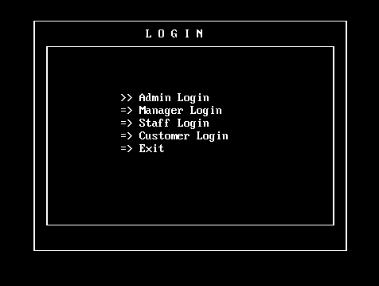

**1.2 Admin Login**

**1.3 Admin Menu**

**1.4 Manager Login**

**1.4 Customer Menu**

**1.6 View Customer**

**1.7 Booking1**

**1.8 Booking2**

